2 October 2025

Dear Applicant,

Thank you for your interest in the post of Head of Fundraising and Communications

In this pack you will find:

- Job Description
- Person Specification

On our website at metrocharity.org.uk/jobs you will find:

- Application Form
- Guidance Notes for Applicants
- Monitoring Form
- Our Equal Opportunities Policy Statement

Please note that CVs will not be considered as part of your application; we will be shortlisting from completed application forms only.

Your completed application form should be sent to arrive no later than 9:00am on Monday 13th of October by email to recruitment@metrocharity.org.uk. Please include your full name in the message subject line. Your email, including attachments, must not exceed 5MB in size. Please also complete the Equality and Diversity monitoring form, which can be found on our website at the link above.

For further information regarding this post please contact Tony Wong by email to tony.wong@metrocharity.org.uk.

We look forward to hearing from you.

Best wishes



Tony Wong, CEO

Key details

Job title | Head of Fundraising and Communications
Employment status | Full Time
Duration | Permanent
Salary/Wage | £51,508
Hours | 35 hours a week, Monday – Friday with some occasional evening and weekend working
Line manager | CEO
Employer | METRO Charity (The Metro Centre Ltd)
Location | Main location of work is METRO Woolwich/METRO New Cross/METRO GAD/METRO Hertfordshire [and across other METRO offices and areas of operation].

Team Structure
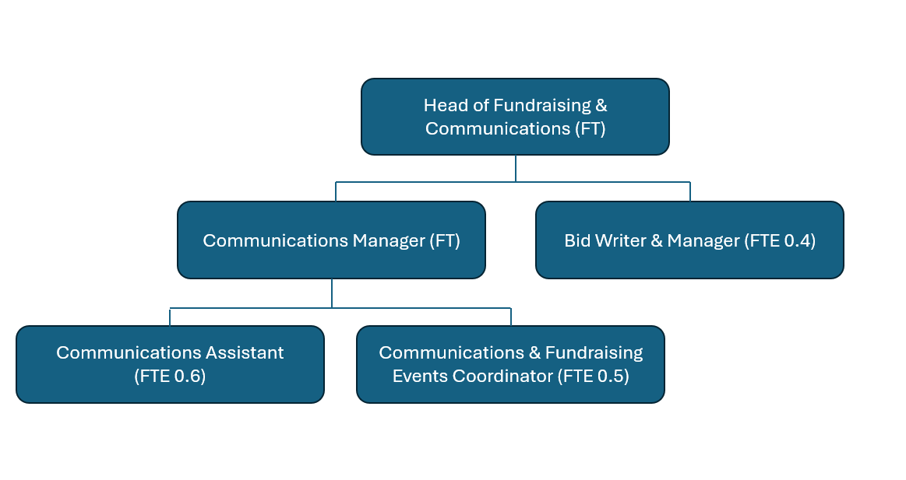

Job Purpose
The Head of Fundraising & Communications is responsible for leading METRO Charity’s fundraising efforts and overseeing the charity’s strategic communications, driving growth through individual giving, legacies, corporate partnerships, community fundraising, and trusts and foundations. This role also encompasses enhancing METRO’s public profile and engagement strategies in alignment with the organisation’s values and goals.

Job outline
The Head of Fundraising & Communications will oversee the development and implementation of comprehensive fundraising strategies and provide oversight of the organisation’s overall communications and engagement with key stakeholders, ensuring alignment with income generation objectives. This role will ensure that fundraising initiatives are effectively integrated with the charity’s strategic communications to develop and engage a strong supporter base.

Main tasks

Fundraising
- Develop and implement a comprehensive fundraising strategy to increase revenue through various channels, including, but not limited to, major gifts, public campaigns, events, and digital fundraising initiatives.
- Proactively develop and maintain strong relationships with key donors, stakeholders, and corporate partners, ensuring alignment with our values, whilst delivering sustainable income streams.
- Lead the integration of fundraising and communications to optimise public engagement and support.
- Develop a monitoring and evaluation framework to ensure the organisation can effectively monitor and measure the impact of fundraising activities and adapt them as necessary.
- Oversee the branding and public relations activities to enhance METRO’s visibility and influence.
- In collaboration with the CEO and executive team, agree on income targets for each of our income generation streams.
- Manage and mentor the fundraising and communications teams, fostering a culture of innovation and excellence.

Communications
- Oversee strategic communications, ensuring cohesive and consistent messaging to promote our charity’s brand awareness amongst key stakeholders.
- Develop and oversee the implementation of a multi-channel communications and engagement strategy to engage key audiences with our work, whether as service users, partners, or supporters.
- Oversee our participation and/or development of key events across the calendar year, ensuring strategic alignment and key fundraising and engagement objectives.
- Manage the communications budget, effectively reviewing expenditure and maximising resource allocation.

Leadership
- Develop and execute domain-specific fundraising and communication strategies, ensuring alignment with METRO’s overall organisational strategy.
- Foster collaboration across departments to ensure seamless service delivery and operational efficiency, integrating fundraising and communication efforts across the organisation.
- Lead and develop the fundraising and communication team, fostering a culture of excellence, continuous learning, and improvement.
- Implement effective risk management practices to identify, record, and respond to risks related to fundraising and communication initiatives.
- Champion the development and implementation of innovative fundraising and engagement strategies, adapting to changing market conditions and organisational goals.

Other duties
- Adhere to METRO policies and procedures at all times.
- In line with METRO’s policy on Information Governance (IG), confidentiality and data handling, you will be expected to undertake, pass and maintain the required IG modules as indicated by your line manager.
- Ensure sensitive and confidential recording and handling of information in accordance with the Data Protection Act, GDPR regulations and METRO’s Information Governance policies.

- In line with METRO’s policy on Safeguarding, you will be expected to undertake, pass and maintain the required Safeguarding Training modules as indicated by your line manager.
- Attend regular supervision, and to undertake appropriate training as agreed. Maintain and update knowledge, skills and undertake continuing education in accordance with personal and service needs within a framework of a personal development plan.
- Engage in continuous professional development and keep abreast of the latest trends in fundraising and nonprofit communications.
- Perform other related duties as assigned by the CEO, ensuring the effective delivery of METRO’s mission and objectives.

Person specification

Knowledge & Experience | Skills & Abilities | Essential  /Desirable | Application  /Interview
Proven experience in leading successful fundraising initiatives and campaigns in a nonprofit environment. |  | Essential
Demonstrable track record in developing and executing strategic communications and engagement strategies, and translating these into operational plans. |  | Essential
Previous responsibility for budget management and financial forecasting in a fundraising context. |  | Essential
A minimum of 3 years’ experience of fundraising mechanisms, including digital fundraising, major gifts, corporate sponsorship, and legacy giving. |  | Essential
Experience in stakeholder engagement, including building relationships with donors, corporate partners, and community leaders. |  | Essential
Experience in the health and social care sector, particularly in areas relevant to METRO Charity’s services. |  | Desirable
Familiarity with international fundraising and engagement strategies. |  | Desirable
Knowledge of the latest trends in charitable giving and digital engagement platforms. |  | Essential
Experience of developing and feeding into monitoring and evaluation frameworks to measure and report on fundraising and communication service performance. |  | Essential

Knowledge & Experience (continued) | Skills & Abilities (continued) | Essential  /Desirable | Application  /Interview
 | Exceptional leadership and people management skills, capable of motivating and developing a high-performing team. | Essential
 | Strong strategic thinking and problem-solving abilities, with a proven capacity to develop strategic plans that align with organisational goals. | Essential
 | Excellent communication skills, both verbal and written, with the ability to articulate complex messages and strategies to a variety of audiences. | Essential
 | Proficiency in using CRM systems to manage donor information and track fundraising progress. | Essential
 | Ability to manage multiple projects simultaneously while maintaining attention to detail and meeting deadlines. | Essential
 | Skills in digital marketing and social media strategy, with a focus on maximising reach and engagement. | Desirable
 | Experience in conducting market analysis to identify and capitalise on fundraising opportunities. | Desirable
 | Ability to innovate and adapt strategies in response to changing market conditions or organisational goals. | Desirable

Other Attributes:
Candidates are expected to demonstrate their value-add to METRO Charity’s culture and their potential to lead the Fundraising & Engagement department through a period of transformational growth. The ability to navigate complex donor relationships and secure funding under tight deadlines will be critical for success in this role.

